**Testing Report**

Right from the beginning that is when we run the program, 75 Shoes are loaded into inventory array, details of which are as follows  
  
Small Shoes are numbered from 1001 to 1030

Medium Shoes are numbered from 2001 to 2020

Large Shoes are numbered from 3001 to 3025

Making a total of 75 shoes.

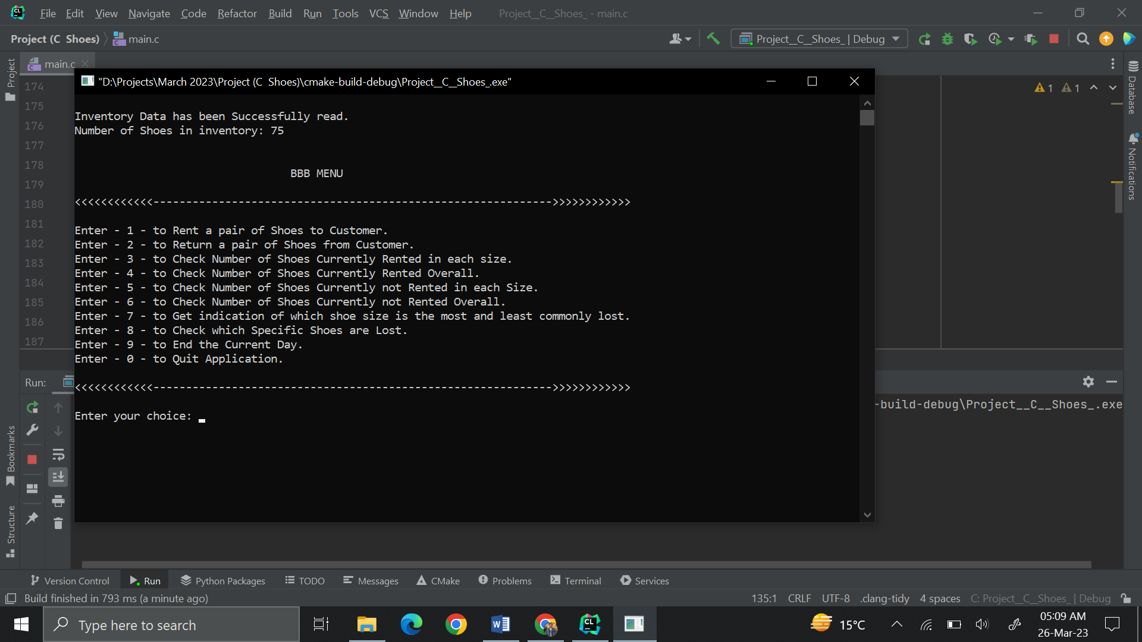

It can also be seen from option number 5 and 6, that shows the total number of shoes that are currently not rented in each size, and overall respectively.

**Testing option 5 and 6:**

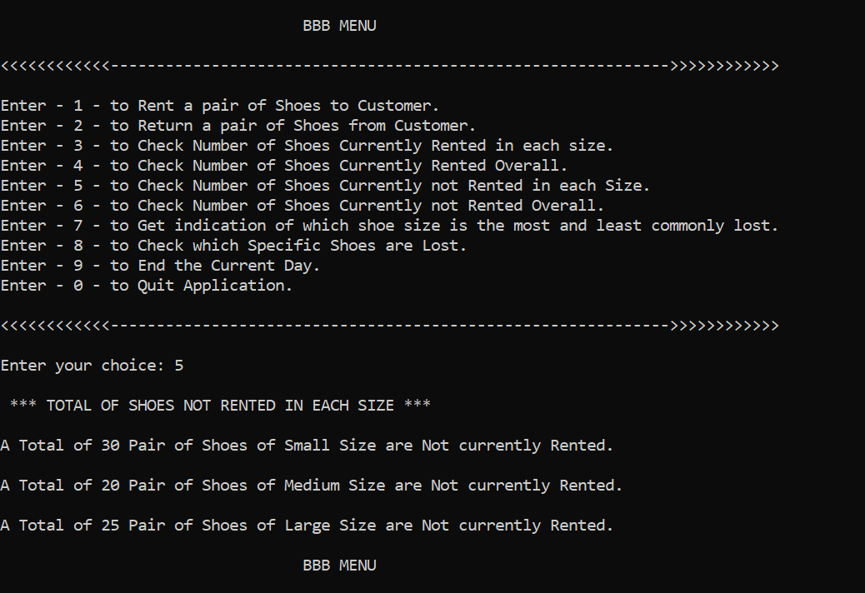

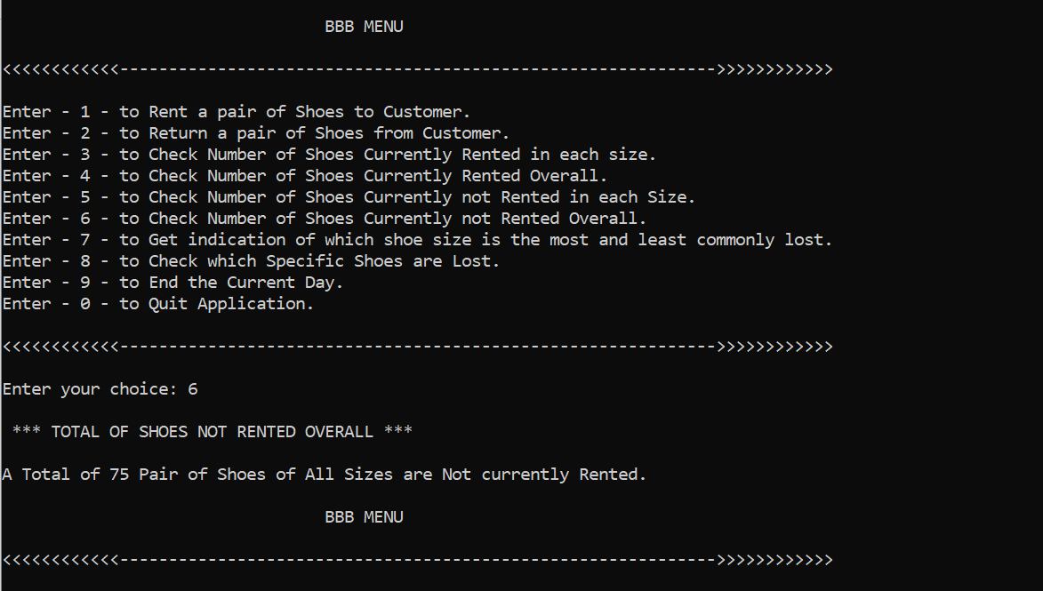

So, we can see that it is loading the correct number of shoes at the start and all of them are not rented in the beginning.

Next, We will rent some of the shoes. Let's say we are going to rent 3 Small, 2 Medium and 6 Large shoes for testing purposes.

We can rent new shoes from option 1 and by specifying the size of the shoes. The application is prone to Wrong Input, it will re-prompt the user in case of wrong input until correct input is given.

**Testing Option 1:**

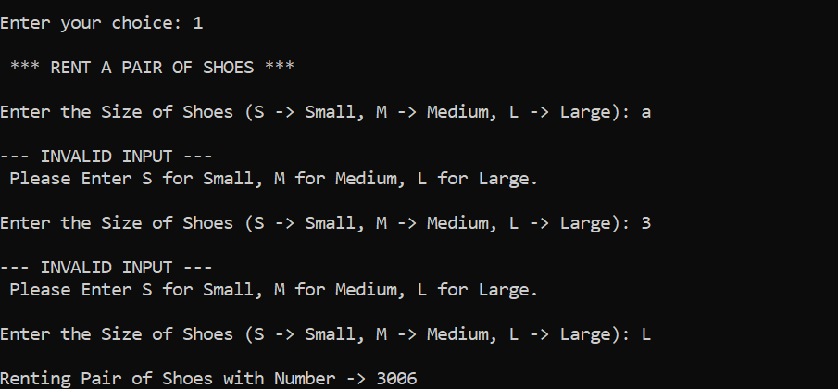

No, To check how many shoes are rented so far, we can use Option 3 and 4 to check a total of rented shoes in each size and overall respectively.

**Testing Option 3 and 4:**

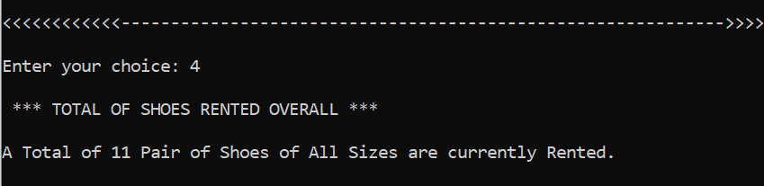

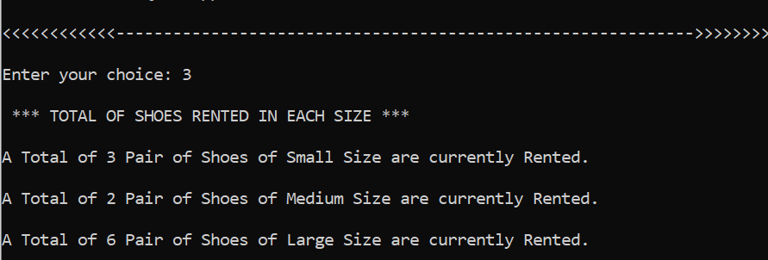

**Testing Option 2:**

To return a shoes back we need to select the option 2, and then set the size and it will mark the specified shoes as not rented. Testing on the above scenario and return 1 Small and 1 Large Shoes,

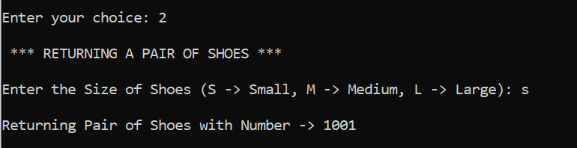

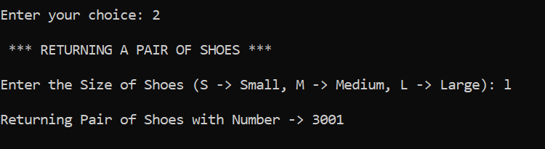

Proof: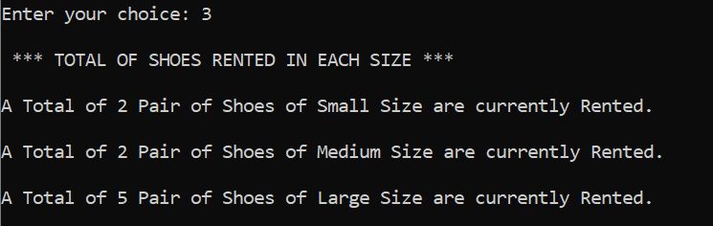

**Testing Option 9:**

The option 9 is used to end the current day, It will play a very important role in our application. When a day is ended, all the rented shoes of that day which are not returned are marked as lost because there are no customers in the BBB. So, if end the day in our scenario, 2 small, 2 medium and 5 large shoes should be lost.

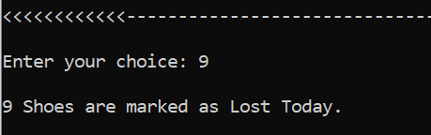

**Testing Option 8:**

Option 8 is the advanced feature, It shows all the Shoes which are lost, If in our scenario it should print 9 shoes.

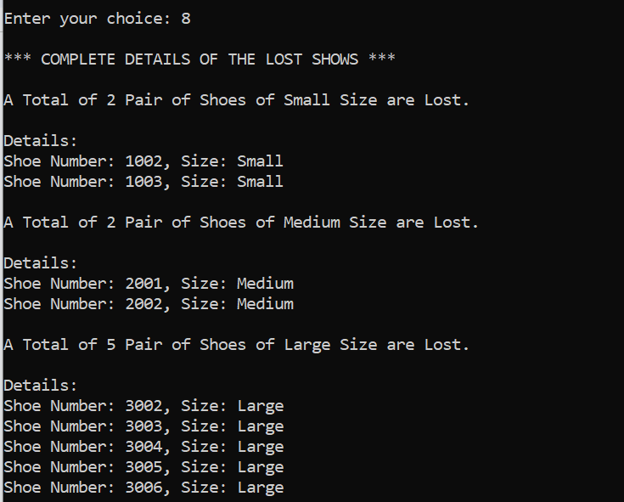

**Testing Option 7:**

Option 7 indicates that which shoes are more commonly lost, it handles all the cases and prints a conjecture based on the previous data that which size of shoes are more likely to be lost. In our scenario we have lost 2 Small, 2 Medium and 5 Large shoes. Let’s check the conjecture  
  
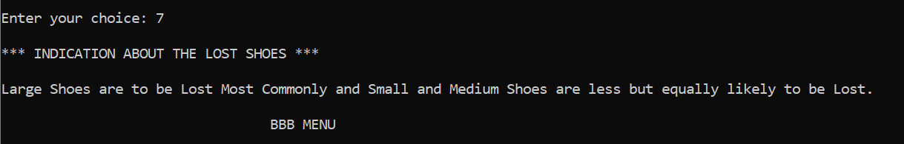

THE END